EEE5931 Electronic Warfare Systems
Problems 2 – Radar Overview: Solutions
November 2026 · Problems from Skolnik, Introduction to Radar Systems, 3rd ed. (Ch. 1–2) · Formulas from the course formula sheet (25-5931 Formul Kagidi)
This document solves the 13 problems listed in Prroblems2-RadarOverview.pdf. The problem texts come from radar_problems.pdf. Problem 2.5 is missing from that file, so its text was taken from the textbook (Skolnik, p. 98). The formulas follow the course formula sheet and Skolnik's notation. A short list of issues found in the sources is at the end.
Constants: c = 3×10⁸ m/s, 1 nmi = 1852 m, 1 ft = 0.3048 m, k = 1.38×10⁻²³ J/K, (4π)² = 157.9.

Problem 1.1 – PRF, round-trip time, range resolution, average power
(a) PRF for R_unamb = 60 nmi. (b) Round-trip time at R_unamb. (c) Pulse extent in space for τ = 1.5 μs. (d) Range resolution. (e) Average power for Pt = 800 kW. (f) Duty cycle.
R_{unamb} = 60 × 1852 = 111 120 m
(a) f_{p} = c / (2R_{unamb}) = 3×10⁸ / 222 240 ≈ 1350 Hz
(b) T_{R} = 2R/c = 222 240 / 3×10⁸ = 741 μs (= 1/f_{p}, the full PRI)
(c) Extent in space = c·τ = 3×10⁸ × 1.5×10⁻⁶ = 450 m
(d) ΔR = c·τ/2 = 225 m
(e) P_{av} = P_{t}·τ·f_{p} = 800×10³ × 1.5×10⁻⁶ × 1350 ≈ 1620 W
(f) Duty cycle = τ·f_{p} = 1.5×10⁻⁶ × 1350 ≈ 2.0×10⁻³ = 0.2 %
The pulse occupies 450 m in space, but two targets only need to be cτ/2 apart: the echo from the farther target travels the extra distance twice, so the echoes separate at half the pulse length.
Answer: f_{p} ≈ 1350 Hz; 741 μs; 450 m; 225 m; P_{av} ≈ 1.62 kW; duty cycle ≈ 0.2 %

Problem 1.2 – L-band air-surveillance radar
f = 1300 MHz, R_max = 200 nmi for σ = 1 m², antenna 12 m × 4 m, ρ_a = 0.65, S_min = 10⁻¹³ W, τ = 2 μs.
λ = c/f = 3×10⁸ / 1.3×10⁹ = 0.231 m; R_{max} = 200 × 1852 = 370 400 m
(a) A = 12 × 4 = 48 m²; A_{e} = ρ_a·A = 0.65 × 48 = 31.2 m²
G = 4πA_{e}/λ² = 4π × 31.2 / 0.0533 ≈ 7360 → G ≈ 38.7 dB
(b) From the simple radar equation R⁴_max = P_{t}·G·A_{e}·σ / ((4π)²·S_{min}):
P_{t} = R⁴·(4π)²·S_{min} / (G·A_{e}·σ) = (1.882×10²²)(157.9)(10⁻¹³) / (7360 × 31.2 × 1) ≈ 1.29×10⁶ W
(c) f_{p} = c/(2R_{unamb}) = 3×10⁸ / 740 800 ≈ 405 Hz
(d) P_{av} = P_{t}·τ·f_{p} = 1.29×10⁶ × 2×10⁻⁶ × 405 ≈ 1050 W
(e) Duty cycle = τ·f_{p} = 2×10⁻⁶ × 405 ≈ 8.1×10⁻⁴ (0.081 %)
(f) θ_{B} ≈ 1.22·λ/D = 1.22 × 0.231 / 12 = 0.0235 rad ≈ 1.34°
The horizontal beamwidth depends on the horizontal dimension (12 m). Skolnik's Ch. 1 rule of thumb θ_{B} ≈ 65λ/D (degrees) gives 1.25°. Either value is acceptable if you state the formula used.
Answer: A_{e} = 31.2 m², G ≈ 7360 (38.7 dB); P_{t} ≈ 1.29 MW; f_{p} ≈ 405 Hz; P_{av} ≈ 1.05 kW; duty ≈ 8.1×10⁻⁴; θ_{B} ≈ 1.3°

Problem 1.3 – Peak power, range and echo power vs range
(a) Peak power for P_av = 200 W, τ = 1 μs, f_p = 1000 Hz. (b) Range for σ = 2 m², f = 2.9 GHz, antenna 5 m × 2.7 m, ρ_a = 0.6, S_min = 10⁻¹³ W. (c) Sketch echo power from 10 to 80 nmi.
(a) P_{t} = P_{av} / (τ·f_{p}) = 200 / (10⁻⁶ × 1000) = 200 kW
(b) λ = 3×10⁸ / 2.9×10⁹ = 0.1034 m; A_{e} = 0.6 × (5 × 2.7) = 8.1 m²
G = 4π × 8.1 / 0.1034² ≈ 9510 (39.8 dB)
R⁴ = P_{t}·G·A_{e}·σ / ((4π)²·S_{min}) = (2×10⁵)(9510)(8.1)(2) / (157.9 × 10⁻¹³) ≈ 1.95×10²¹ m⁴
R ≈ 2.10×10⁵ m ≈ 113.5 nmi
(c) P_{r} = P_{t}·G·A_{e}·σ / ((4π)²R⁴) falls as 1/R⁴, so it drops 12 dB every time the range doubles (40 dB per decade).
R (nmi) | 10 | 20 | 40 | 60 | 80
P_{r} (W) | 1.66×10⁻⁹ | 1.04×10⁻¹⁰ | 6.5×10⁻¹² | 1.28×10⁻¹² | 4.0×10⁻¹³
P_{r} (dBm) | −57.8 | −69.8 | −81.9 | −88.9 | −93.9

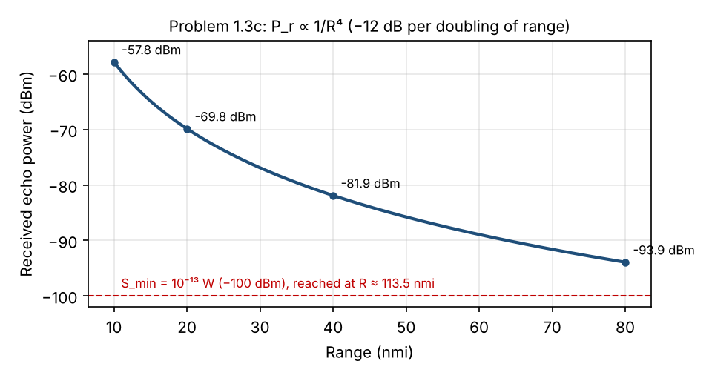
Answer: P_{t} = 200 kW; R_{max} ≈ 113.5 nmi; P_{r} ∝ 1/R⁴ (from about −58 dBm at 10 nmi to −94 dBm at 80 nmi)

Problem 1.5 – Automotive X-band radar
f = 9375 MHz, τ = 10 ns, R_max = 500 ft. (a) PRF. (b) Range resolution. (c) Cross-range resolution for a 6° beam. (d) Gain of a 1 ft × 1 ft antenna, ρ = 0.6. (e) Average power for σ = 10 m², S_min = 5×10⁻¹³ W.
R = 500 ft = 152.4 m; λ = 3×10⁸ / 9.375×10⁹ = 0.032 m
(a) f_{p} = c/(2R) = 3×10⁸ / 304.8 ≈ 984 kHz
(b) ΔR = c·τ/2 = 3×10⁸ × 10⁻⁸ / 2 = 1.5 m
(c) Δx = R·θ_{B} = 152.4 × (6° × π/180) = 152.4 × 0.1047 ≈ 16 m
This is not sufficient. A traffic lane is about 3.5 m wide, so at 500 ft the beam covers about four lanes plus the roadside. The radar cannot tell whether the echo comes from the car in its own lane, a car in the next lane, or a sign or guardrail.
(d) A = 0.3048² = 0.0929 m²; A_{e} = 0.6 × 0.0929 = 0.0557 m²
G = 4πA_{e}/λ² = 4π × 0.0557 / 0.032² ≈ 684 → G ≈ 28.4 dB
(e) P_{t} = R⁴·(4π)²·S_{min} / (G·A_{e}·σ) = (152.4)⁴(157.9)(5×10⁻¹³) / (684 × 0.0557 × 10) ≈ 1.1×10⁻⁴ W
P_{av} = P_{t}·τ·f_{p} = 1.1×10⁻⁴ × 10⁻⁸ × 9.84×10⁵ ≈ 1.1×10⁻⁶ W (≈ 1.1 μW)
The required power is tiny because the range is very short and R appears to the fourth power.
Answer: f_{p} ≈ 984 kHz; ΔR = 1.5 m; cross-range ≈ 16 m (not sufficient); G ≈ 28.4 dB; P_{av} ≈ 1.1 μW (P_{t} ≈ 0.11 mW)

Problem 1.6 – Minimum-cost radar design
f = 1230 MHz, ρ_a = 0.6, S_min = 3×10⁻¹³ W, transmitter $2.20 per watt of peak power, antenna $1400 per m², other items $1 000 000. Detect σ = 2 m² at 200 nmi.
Step 1: relation between P_{t} and A. Use the simple radar equation with G = 4πA_{e}/λ² and A_{e} = ρ_a·A:
R⁴ = P_{t}·G·A_{e}·σ / ((4π)²S_{min}) = P_{t}·A_{e}²·σ / (4π·λ²·S_{min})
P_{t}·A² = 4π·λ²·S_{min}·R⁴ / (σ·ρ_a²) ≡ K
λ = 0.244 m, R = 370 400 m → K = 4π(0.0595)(3×10⁻¹³)(1.882×10²²) / (2 × 0.36) ≈ 5.86×10⁹ W·m⁴
Step 2: minimize the cost. With P_{t} = K/A²:
C(A) = 2.2·K/A² + 1400·A + 10⁶
dC/dA = −2(2.2)K/A³ + 1400 = 0 → A³ = 4.4K/1400 → A ≈ 264 m²
P_{t} = K/A² = 5.86×10⁹ / 264² ≈ 84 kW
(a) Antenna cost = 1400 × 264 ≈ $370 000; Transmitter cost = 2.2 × 84 000 ≈ $185 000
Total ≈ $370 000 + $185 000 + $1 000 000 ≈ $1.55 M
(b) At the optimum, dC/dA = 0 gives 1400·A = 2 × (2.2·P_{t}): antenna cost = 2 × transmitter cost. As a first attempt, put about two thirds of the antenna-plus-transmitter budget into the antenna and one third into the transmitter. This works because P_{t} ∝ 1/A², so money spent on the antenna reduces the required power quadratically. (Check: G = 4πρ_aA/λ² ≈ 45 dB.)
Answer: A ≈ 264 m², P_{t} ≈ 84 kW; antenna ≈ $370 k, transmitter ≈ $185 k; rule: antenna cost ≈ 2 × transmitter cost

Problem 1.9 – Minimum-weight radar
W_T = k_T·P, W_A = k_A·A^(3/2). Find the relation between W_A and W_T that minimizes W = W_T + W_A at fixed range.
As in Problem 1.6, at a fixed range the radar equation gives P·A² = K (constant), so P = K/A².
W(A) = k_{T}·K/A² + k_{A}·A^(3/2)
dW/dA = −2k_{T}·K/A³ + (3/2)k_{A}·A^(1/2) = 0
Multiply by A: −2(k_{T}·K/A²) + (3/2)(k_{A}·A^(3/2)) = 0, that is −2W_{T} + (3/2)W_{A} = 0:
W_{A} = (4/3)·W_{T}
In general, if the antenna cost or weight scales as A^m and P ∝ 1/A², the optimum is (antenna share) = (2/m) × (transmitter share). With m = 1 this gives the factor 2 of Problem 1.6; with m = 3/2 it gives 4/3.
Answer: Minimum total weight when W_{A} = (4/3)·W_{T}: the antenna weighs one third more than the transmitter.

Problem 2.5 – False-alarm time and threshold
T_fa = 30 min, B = 0.4 MHz. (a) P_fa. (b) Threshold-to-noise ratio V_T²/ψ₀. (c) Repeat for T_fa = 1 year (8760 h). (d) Threshold set 0.3 dB lower than (b): new T_fa? (e) Threshold 0.3 dB higher: new T_fa? (f) Comment on achieving a specified T_fa precisely. [Text from Skolnik p. 98]
Formula sheet: P_{fa} = 1/(T_{fa}·B) and T_{fa} = (1/B)·exp(V_{T}²/2ψ₀), so V_{T}²/ψ₀ = 2·ln(T_{fa}·B).
(a) T_{fa}·B = 1800 × 4×10⁵ = 7.2×10⁸ → P_{fa} = 1/(7.2×10⁸) ≈ 1.39×10⁻⁹
(b) V_{T}²/ψ₀ = 2·ln(7.2×10⁸) = 2 × 20.40 = 40.8 → 16.1 dB
(c) T_{fa} = 8760 × 3600 = 3.15×10⁷ s; T_{fa}·B = 1.26×10¹³ → P_{fa} ≈ 7.9×10⁻¹⁴
V_{T}²/ψ₀ = 2·ln(1.26×10¹³) = 60.3 → 17.8 dB
(d) −0.3 dB: V_{T}²/ψ₀ = 40.8 × 10^(−0.03) = 38.07 → T_{fa} = exp(19.03)/(4×10⁵) ≈ 461 s ≈ 7.7 min
(e) +0.3 dB: V_{T}²/ψ₀ = 40.8 × 10^(0.03) = 43.71 → T_{fa} = exp(21.85)/(4×10⁵) ≈ 7740 s ≈ 2.15 h
(f) The false-alarm time depends exponentially on the threshold. A change of only ±0.3 dB moves T_{fa} from 30 min to between 8 min and 2 h. Going from 30 minutes to one year (17 500 times longer) needs only 1.7 dB more threshold. Setting a specific T_{fa} precisely would require knowing the noise level and receiver gain to a small fraction of a dB, which is not practical with drift, temperature changes and interference. Real radars therefore use CFAR (constant false-alarm rate) processing, which estimates the noise level and adjusts the threshold automatically.
Answer: P_{fa} ≈ 1.4×10⁻⁹, V_{T}²/ψ₀ ≈ 40.8 (16.1 dB); 1 year: P_{fa} ≈ 7.9×10⁻¹⁴, 60.3 (17.8 dB); −0.3 dB → ≈ 7.7 min; +0.3 dB → ≈ 2.2 h; T_{fa} is extremely sensitive to the threshold.

Problem 2.8 – Pulses per scan and integration
f = 1.35 GHz, D = 32 ft, R_unamb = 220 nmi, scan time 10 s. (a) Number of pulses per scan (θ_B = 1.2λ/D). (b) Integration loss and integration-improvement factor for P_d = 0.9, P_fa = 10⁻⁶.
λ = 3×10⁸ / 1.35×10⁹ = 0.222 m; D = 32 × 0.3048 = 9.75 m
θ_{B} = 1.2λ/D = 1.2 × 0.222 / 9.75 = 0.0273 rad = 1.57°
f_{p} = c/(2R_{unamb}) = 3×10⁸ / (2 × 407 440) ≈ 368 Hz
θ̇_s = 360° / 10 s = 36°/s
(a) n = θ_{B}·f_{p} / θ̇_s = 1.57 × 368 / 36 ≈ 16 pulses
(b) From Skolnik Fig. 2.7 (square-law detector, Marcum), at n = 16, P_{d} = 0.9 and n_{f} = 1/P_{fa} = 10⁶ (between the 10⁴ and 10¹² curves):
I_{i}(16) ≈ 9 (≈ 9.5 dB); L_{i}(16) ≈ 2.5 dB
Numerical check (noncoherent integration of 16 pulses, nonfluctuating target): the single-pulse requirement is (S/N)₁ = 13.2 dB and the per-pulse requirement with 16 pulses is (S/N)₁₆ = 3.8 dB. Hence:
I_{i} = (S/N)₁/(S/N)₁₆ = 13.2 − 3.8 = 9.4 dB (≈ 8.6); E_{i} = I_{i}/n ≈ 0.54; L_{i} = 10·log(1/E_{i}) ≈ 2.7 dB
Interpretation: with perfect (coherent) integration, 16 pulses would give a 12 dB improvement. Noncoherent integration gives about 9.4 dB, so about 2.5–2.7 dB is lost.
Answer: n ≈ 16 pulses; I_{i} ≈ 9 (≈ 9.4 dB); L_{i} ≈ 2.5–2.7 dB

Problem 2.10 – Maximum RCS of a metallic sphere
In Skolnik Fig. 2.8, the RCS of a sphere peaks in the resonance (Mie) region at 2πa/λ = 1, where the circumference equals one wavelength. The peak is 5.6 dB above the optical-region value, so σ_{max} ≈ 3.6·πa².
(a) D = 1 m (a = 0.5 m): λ = 2πa = π m ≈ 3.14 m → f = c/λ ≈ 95.5 MHz (σ_{max} ≈ 3.65 × 0.785 ≈ 2.9 m²)
(b) D = 1 mm (a = 0.5 mm): λ = π mm → f ≈ 95.5 GHz (σ_{max} ≈ 2.9×10⁻⁶ m²)
The result scales with size: making the sphere 1000 times smaller moves the peak 1000 times higher in frequency.
Answer: (a) ≈ 95.5 MHz; (b) ≈ 95.5 GHz

Problem 2.11 – License plate RCS
Plate 12 in × 6 in, f = 10.525 GHz. (a) Maximum RCS. (b) Vertical tilt for −10 dB. (c) Other contributors to a car's frontal RCS.
λ = 3×10⁸ / 10.525×10⁹ = 0.0285 m; A = 0.3048 × 0.1524 = 0.0465 m²
(a) σ_{max} = 4πA²/λ² = 4π × 0.0465² / 0.0285² ≈ 33.4 m² (15.2 dBsm)
A small flat plate is a strong reflector at normal incidence: 33 m² is comparable to a whole aircraft.
(b) With H = 6 in = 0.1524 m, H/λ = 5.35. Let x = 2π(H/λ)·sin ϕ. Find x where sin²x / x² = 0.1 (−10 dB):
sin x / x = 0.316 → x ≈ 2.32 rad
sin ϕ = x / (2π × 5.35) = 2.32 / 33.6 = 0.069 → ϕ ≈ 4.0°
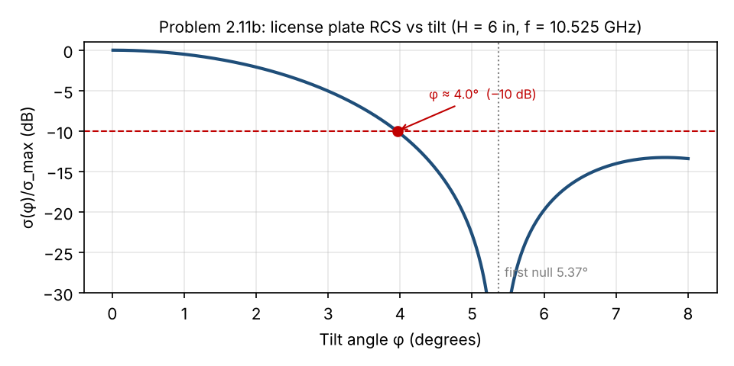
The first null is at x = π (ϕ ≈ 5.4°), so a tilt of only about 4° reduces the RCS by 10 dB.
(c) Other contributors from the front: the headlight reflectors (parabolic mirrors behind the lens act like corner and dish reflectors), the bumper and grille, the radiator and engine block seen through non-metallic parts, dihedral and corner structures (bumper–body joints, hood–windshield junction, wheel wells), the windshield frame, side mirrors, and the license plate bracket. Multiple reflections between the car and the road surface also add to the echo.
Answer: σ_{max} ≈ 33 m²; tilt ≈ 4° for −10 dB; headlights, grille/bumper, radiator/engine, corner-like structures, mirrors

Problem 2.18 – Single-pulse SNR: nonfluctuating vs Swerling 1
P_{fa} = 10⁻⁶, detection on a single pulse. The nonfluctuating values come from Skolnik Fig. 2.6 (equivalently Albersheim's equation or the exact Marcum calculation). For a Swerling 1 target with one pulse there is an exact closed form: P_{d} = P_{fa}^(1/(1+S/N)), so S/N = ln(P_{fa})/ln(P_{d}) − 1.
(a) Nonfluctuating, P_{d} = 0.50: S/N ≈ 11.2 dB
(b) Nonfluctuating, P_{d} = 0.99: S/N ≈ 14.5 dB
(c) Swerling 1, P_{d} = 0.50: S/N = ln(10⁻⁶)/ln(0.5) − 1 = 19.93 − 1 = 18.9 → 12.8 dB
Swerling 1, P_{d} = 0.99: S/N = 13.82/0.01005 − 1 ≈ 1374 → 31.4 dB
P_{d} | Nonfluctuating | Swerling 1 | Fluctuation loss L_{f}
0.50 | 11.2 dB | 12.8 dB | ≈ 1.5 dB
0.99 | 14.5 dB | 31.4 dB | ≈ 17 dB

(d) Conclusions:
- For a nonfluctuating target, going from P_{d} = 0.5 to 0.99 costs only about 3 dB.
- For a fluctuating (Swerling 1) target, the same step costs about 19 dB, because a deep fade of the echo occasionally makes detection impossible no matter how good the average SNR is.
- At P_{d} = 0.5 the fluctuation loss is small (~1.5 dB), but at high P_{d} it is very large (~17 dB). Demanding very high single-pulse P_{d} against fluctuating targets is extremely expensive.
- In practice, high P_{d} is obtained by integrating several pulses and by decorrelating the target fluctuations (for example frequency agility or diversity), not by raising the power.
Answer: 11.2 / 14.5 dB (nonfluctuating); 12.8 / 31.4 dB (Swerling 1); fluctuation loss grows from ~1.5 dB to ~17 dB

Problem 2.19 – Resolving range ambiguity with two PRFs
R_{u1} = c/(2·4000) = 37.5 km = 20.25 nmi; R_{u2} = c/(2·3500) = 42.86 km = 23.14 nmi
The true range must satisfy both measurements: R = 7 + m·20.25 = 18.6 + k·23.14 for integers m and k. Try m = 0, 1, 2, …
m | R = 7 + 20.25m (nmi) | R − 18.6 | Multiple of 23.14?
1 | 27.25 | 8.65 | No
2 | 47.50 | 28.90 | No
3 | 67.75 | 49.15 | No (2 × 23.14 = 46.28)
4 | 88.00 | 69.40 | Yes (3 × 23.14 = 69.42)

R_{true} = 7 + 4 × 20.25 = 18.6 + 3 × 23.14 ≈ 88 nmi
Answer: True range ≈ 88 nmi

Problem 2.20 – Cosecant-squared antenna pattern
(a) For an aircraft at constant height h over a flat earth, the elevation angle satisfies sin ϕ = h/R, so csc ϕ = R/h. With the same antenna for transmit and receive:
P_{r} = P_{t}·G²·λ²·σ / ((4π)³R⁴), G = G₀·csc²ϕ = G₀·(R/h)²
P_{r} = P_{t}·G₀²·(R/h)⁴·λ²·σ / ((4π)³R⁴) = P_{t}·G₀²·λ²·σ / ((4π)³h⁴)
The R⁴ terms cancel, so the received power depends only on the height h and not on range R.
(b) A simple fan beam that is narrow in elevation leaves a gap at high elevation angles: an aircraft that comes close to the radar at altitude leaves the beam. The csc² pattern spreads the energy in elevation so that coverage extends up to a constant-altitude ceiling at all ranges. It also avoids wasting power at short range and high angles, where a fan beam would give much more signal than needed.
(c) Limitations of the simple result:
- The earth is not flat: curvature and atmospheric refraction change the geometry at long range.
- Ground reflections (multipath) create lobes and nulls in the elevation pattern.
- A real antenna only approximates csc² over a limited range of angles (G cannot become infinite as ϕ → 0). The shaped beam also has lower peak gain (about 2 dB) than an unshaped fan beam of the same size.
- The target RCS is not constant: it changes with aspect angle and fluctuates.
- Aircraft do not fly at exactly constant height, and the effect of the antenna's azimuth pattern and propagation losses is ignored.
Answer: P_{r} = P_{t}·G₀²·λ²·σ/((4π)³h⁴), independent of R; csc² gives coverage up to a constant altitude without wasting power; limitations: earth curvature, multipath, real antenna patterns, RCS variation

Issues Found in the Sources
Where | Issue | Comment
radar_problems.pdf | Problem 2.5 is missing (the Chapter 2 list starts at 2.7). | Text taken from Skolnik, 3rd ed., p. 98.
Formula sheet | The integration line reads "E_{i}(n) = (S/N)_{n} = (S/N)₁/n". | (S/N)_{n} = (S/N)₁/n holds only for ideal (coherent) integration. The definition is E_{i}(n) = (S/N)₁ / [n·(S/N)_{n}] (Skolnik Eq. 2.32), with I_{i} = n·E_{i} and L_{i} = 10·log(1/E_{i}).
Problem 1.2f / formula sheet | Beamwidth constant differs between sources: 1.22λ/D (formula sheet), 1.2λ/D (Problem 2.8), 65λ/D in degrees (Skolnik Ch. 1). | Results differ by ~10 %. State which formula you use.
Problem 2.8b | Skolnik Fig. 2.7 uses Marcum's false-alarm number n_{f}; reading it at n_{f} = 10⁶ requires interpolating between the 10⁴ and 10¹² curves. | Figure gives I_{i} ≈ 9, L_{i} ≈ 2.5 dB; the exact calculation gives 8.6 and 2.7 dB.

Sources
- M. I. Skolnik, Introduction to Radar Systems, 3rd ed., McGraw-Hill, 2001: Ch. 1, Ch. 2 (Eqs. 2.21, 2.32; Figs. 2.6, 2.7, 2.8; problems p. 98–103).
- EEE5931 course notes 26-03 Radar Overview and the course formula sheet (25-5931 Formul Kagidi).

